Url Slug Suggestion - https://rootcabs.com/services/auto
Primary Keyword
book auto
book auto online
Secondary Keyword
auto rickshaw booking app
book auto near me
online auto booking
auto booking near me
online auto booking app
auto rickshaw booking app
auto cab booking
Page Layout

H1 - Book Auto Online


H2 - What Makes Root Cabs Auto Different?
H2 - Benefits of the online auto booking

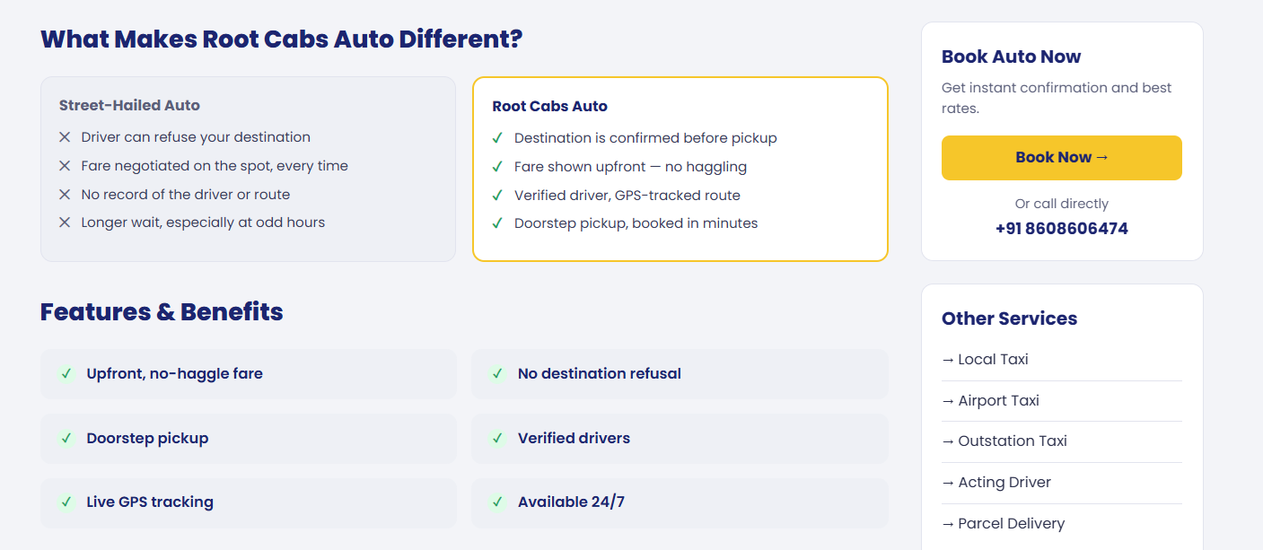

H2 - Safety for Late-Night & Solo Riders

H3 - Verified Drivers
H3 - Live Tracking
H3 - 24/7 Availability
H3 - Private Contact Details
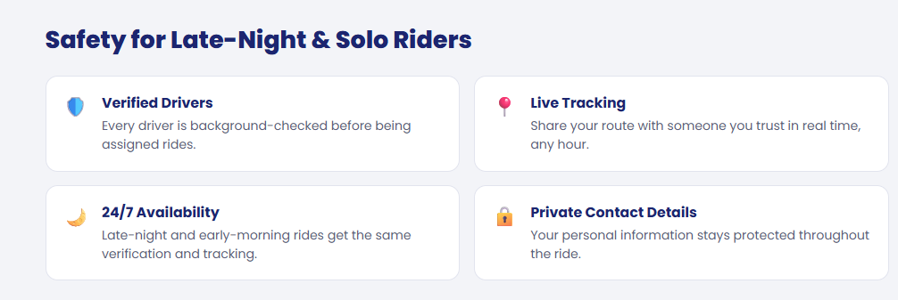

H2 - How It Works

H3 - Enter pickup & drop
H3 - See the fare, confirm
H3- Ride, tracked

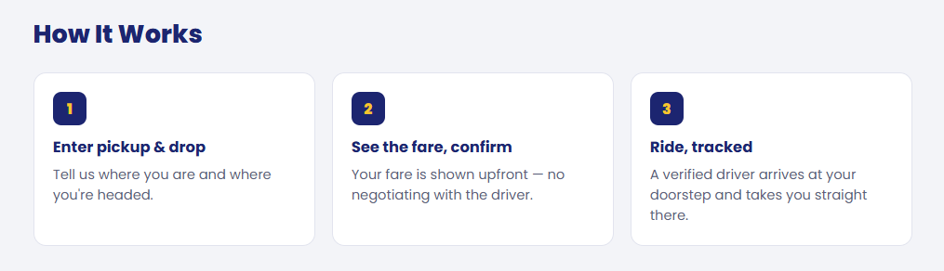

H2 - Available In Book Auto Online

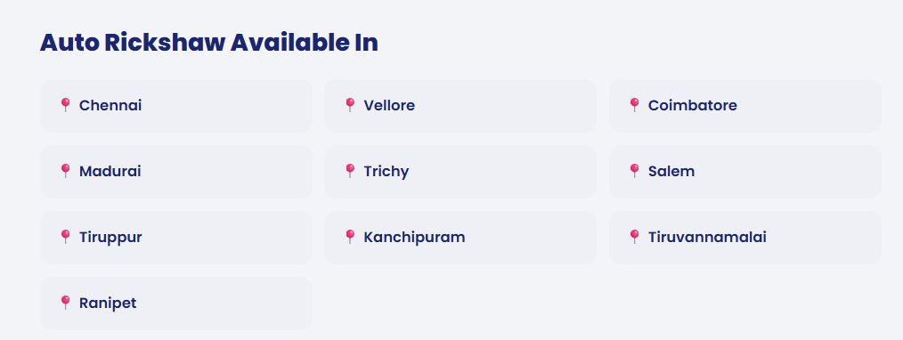

H2 -

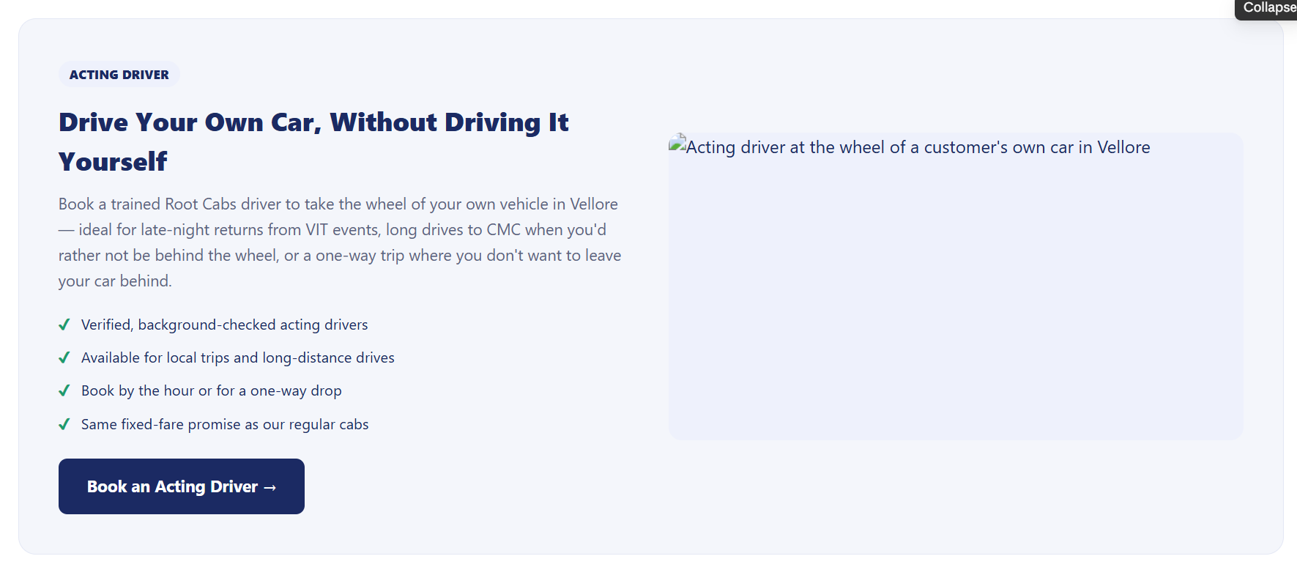

Acting driver section added - Purpose interlinking to the acting driver page.
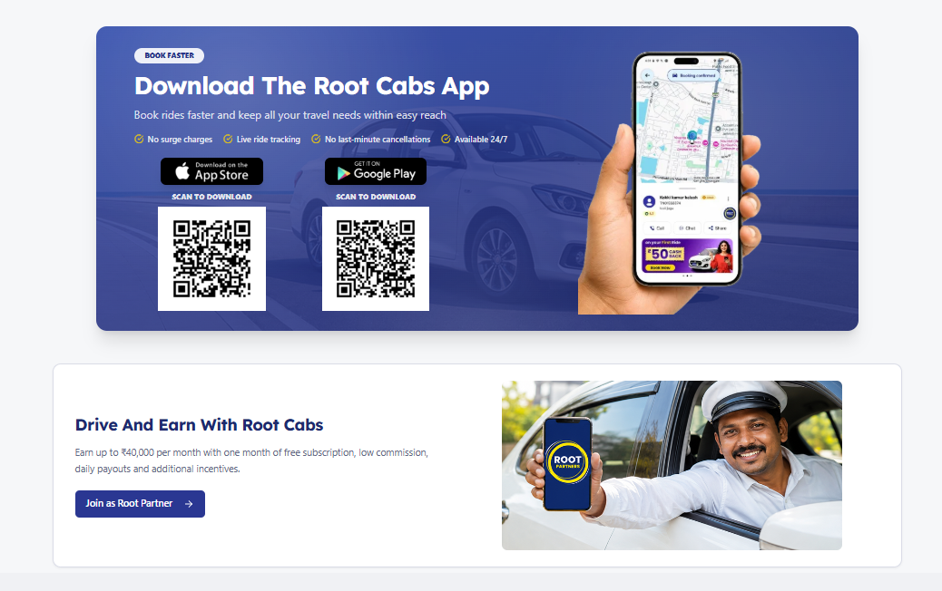

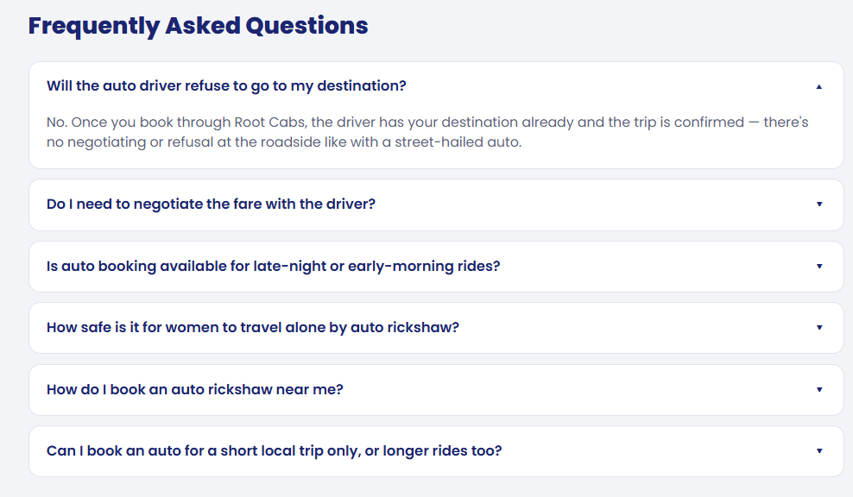
How is Root Cabs Auto different from a regular street-hailed auto?
Can I choose or request a specific type of auto?
Is there a cancellation fee if I cancel after booking an auto?
What payment methods are accepted for auto rides?
How is the driver assigned nearest available, or something else?

